ASSIGNMENT-2

1.Write PL/SQL block which will give a raise in salary to employees as per the following: If sal+comm=5000 increase by 500 + 12% of above 7000.

CREATE TABLE emp(
id number(3) constraint fk_id primary key,
ename varchar2(20) not null,
sal number(4) not null,
comn number(4)); DESC emp

insert into emp values (101,'Rakesh',5000,500);
insert into emp values (102,'Gaurav',2000,500);
insert into emp values (103,'Prakash',3300,500);
insert into emp values (104,'Mansukh',10000,500);
insert into emp values (105,'Pinki',5200,500);
insert into emp values (106,'Golu',6010,500);
insert into emp values (107,'Jayesh',1000,500);
insert into emp values (108,'Jaynit',7000,500);
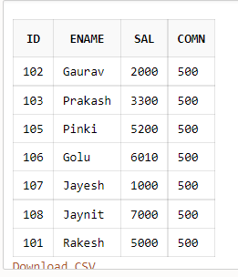
PL/SQL code:
declare
cursor c1 is
select id,ename,sal,comn from emp;
newsal number(4);
begin
for c2 in c1
loop
if c2.sal+c2.comn<5000 then
newsal:=c2.sal+c2.sal*0.10;
elsif c2.sal+c2.comn>3000 then
newsal:=c2.sal+500;
else
newsal:=c2.sal+500+c2.sal*0.12;
end if;
dbms_output.put_line(c2.id||' '||c2.ename||' '||c2.sal||' '||c2.comn||' '||newsal);
end loop;
end;

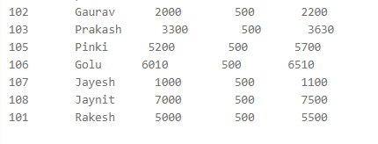

2.Suppose you have created the following three tables in your database: PART_MASTER(P#,PNAME,PRICE,TOT_QTY,REORDER_LEVEL) PART_TRANS(O#,P#,QTY_REQ),where O# is the order no. TEMP(P#,QTY) Write a PL/SQL block which will read records one by one from the transaction table and will check whether after issuing this part, the total quantity of this part is going below the reorder level in the master table or not. If it is then that part is not to be issued, hence give appropriate message and enter the details of this part in TEMP table. If the total quantity after issuing that part is not going below the reorder level then modify the master table accordingly.

CREATE TABLE part_master(
p NUMBER(2) PRIMARY KEY,
pname VARCHAR2(30),
price NUMBER(3),
tot_qty NUMBER(3),
reorder_leavel NUMBER(3) );

insert into part_master values(1,'Bulb',160,12,2);
insert into part_master values(2,'LED',50,39,20);
insert into part_master values(3,'Remote',55,40,20);
insert into part_master values(4,'Charger',520,10,1);
insert into part_master values(5,'shoes',390,5,2);

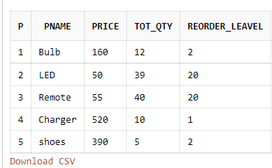

CREATE TABLE part_trans(

o NUMBER(2),
p NUMBER(2) ,
qty_req NUMBER(2),
PRIMARY KEY (p,o),FOREIGN KEY (p) REFERENCES PART_MASTER(p));

insert into part_trans values(1,2,30);
insert into part_trans values(2,3,40);
insert into part_trans values(3,4,15);
insert into part_trans values(4,2,15);
insert into part_trans values(5,1,7);
insert into part_trans values(6,5,3);
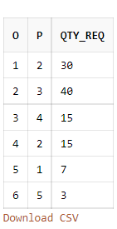

CREATE TABLE TEMP(P NUMBER(2),QTY_REQ NUMBER (2),FOREIGN KEY (P) REFERENCES PART_MASTER(P));

PL/SQL
declare
p number(2);
tq number(3);
ro number(3);
qr number(2);
n number(2);
cursor c is select a.p,a.tot_qty,a.REORDER_LEAVEL,b.qty_req from part_master a,part_trans b
where a.p=b.p;
begin
open c;
loop
fetch c into p,tq,ro,qr;
exit when c%notfound;
n:=tq-ro;
if n<0 then
dbms_output.put_line(' we dont have that much items');
insert into temp values(p,qr);
else
if n<ro then
dbms_output.put_line(' we are not able to provide you this no. of parts
');
insert into temp values(p,qr);
end if;
if n>ro then
update part_master set tot_qty=n where p=part_master.p;
end if;
end if;
end loop;
close c;
end;

part_master - TABLE
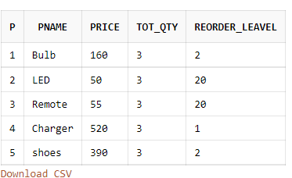
Part_Trans -TABLE
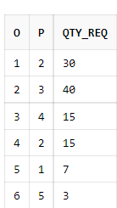

Temp-TABLE
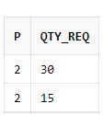

3.Given a table ISSUE(ROLLNO,BOOKNO,ISSUE_DATE,RETURN_DATE), check which students have to pay fine and the amount of fine to be paid. A Student can keep the book for fifteen days. If the number of days has exceeded 15 then fine is calculated as follow: Upto 7 days 50 paise per day 8-15 Rs.1 per day from 8th day onwards More than 15 days Rs. 1.5per day from 16th day onwards After calculating the fine store the required information in the FINE table so that a report can later on printed out.

create table issue(
rollno number(3),
bookno number(3) primary key,
issue_date date,
return_date date );

insert into issue values(570,181,'01-JAN-2022','02-FEB-2022');
insert into issue values(512,199,'04-MARCH-2022','05-MARCH-2022');
insert into issue values(516,100,'03-NOV-2022','02-DEC-2022');
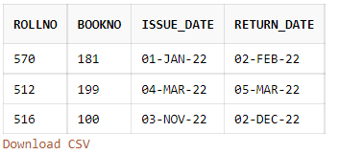

create table fine(
rollno number(3),
bookno number(3),
fine_amount number(4,2),
foreign key(bookno) references issue(bookno) );

declare
rollno number(3);
bookno number(3);
issue_date date;
return_date date;
fine number(4,2);
days_up number(2);
cursor c2 is select rollno,bookno,issue_date,return_date from issue;
begin
open c1;
loop
fetch c1 into rollno,bookno,issue_date,return_date;
exit when c2%notfound;
fine:=0;
days_up:=return_date-issue_date;
if days_up>15 and days_up<22 then
fine:=days_up*0.5;
else if days_up>15 and days_up<30 then
fine:=days_up;
else if days_up>15 and days_up>30 then
fine:=days_up*1.5;
else
fine:=0;
end if;
insert into fine values(rollno,bookno,fine);
endloop;
close c2;
end;

ASSIGNMENT-3

1.Write a PL/SQL block for the following tableas per the requirement :CANDIDATE (SEAT_NO, FORM_NO, NAME, CATEGORY, PERCENTAGE)Except the seat numbers, all other information regarding the candidates appearing in the MCA entrance test is available in the CANDIDATE table. Seat numbers are to be generated as per the following: Seat numbers are 8 characters in length. The first three characters are ‘111’. The fourth character represents the category to which the candidate belongs. The rest of the four characters are used to denote the rank of the candidate as per his percentage, category-wise. For e.g., a candidate belonging to the GENERAL category and having secured the highest percentage amongst all other candidates in the same category will have a seat number as ‘11120001’, where ‘2’ is the code for the GENERAL category. In this way generate the seat numbers for all the candidates in the CANDIDATE table. Please mention any assumptions that you make. The codes for the different categories are

create table candidate(
seat_no number(8) default null,
form_no number(6) primary key,
name varchar2(20),
category varchar2(10),
percentage number(4) );

insert into candidate (form_no,name,category,percentage) values(1,'GAUTAM','GENERAL',85);
insert into candidate (form_no,name,category,percentage) values(2,'RAVI','SEBC',90);
insert into candidate (form_no,name,category,percentage) values(3,'SOM','SC',73);
insert into candidate (form_no,name,category,percentage) values(4,'KEVAL','ST',80);
insert into candidate (form_no,name,category,percentage) values(5,'KENIL','ST',60);
insert into candidate (form_no,name,category,percentage) values(6,'PRITI','ST',75);
insert into candidate (form_no,name,category,percentage) values(7,'KAJAL','ST',55);
insert into candidate (form_no,name,category,percentage) values(8,'SAGAR','SC',60);
insert into candidate (form_no,name,category,percentage) values(9,'ROYAL','PH',80);
insert into candidate (form_no,name,category,percentage)
values(10,'RAJIV','GENERAL',85);
insert into candidate (form_no,name,category,percentage) values(11,'RAKESH','SC',78);
insert into candidate (form_no,name,category,percentage) values(12,'AKASH','SEBC',85);
insert into candidate (form_no,name,category,percentage) values(13,'KEYUR','SEBC',90);
insert into candidate (form_no,name,category,percentage) values(14,'JAIMIN','SEBC',40);
insert into candidate (form_no,name,category,percentage) values(15,'KOMAL','SEBC',36);

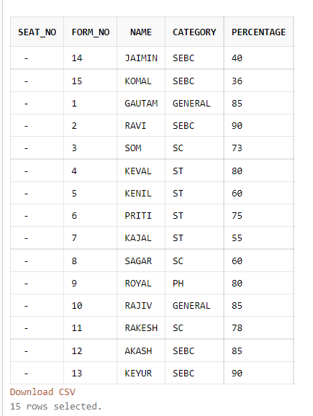

PL/SQL

declare
cursor c1 is
select * from candidate
order by category asc,percentage desc;
i candidate.seat_no%type;
cat candidate.category%type;
begin
i:=11120000;
cat:='GENERAL';
for r1 in c1
loop
if(r1.category<>cat)
then
case
when r1.category='GENERAL'
then i:=11120000;

when r1.category='SC'
then i:=11130000;

when r1.category='ST'
then i:=11140000;

when r1.category='SEBC'
then i:=11150000;
when r1.category='PH'
then i:=11160000;
end case;
end if;
i:=i+1;
update candidate set seat_no=i
where form_no=r1.form_no;

cat:=r1.category;
end loop;
commit;
end;
/
select * from candidate;

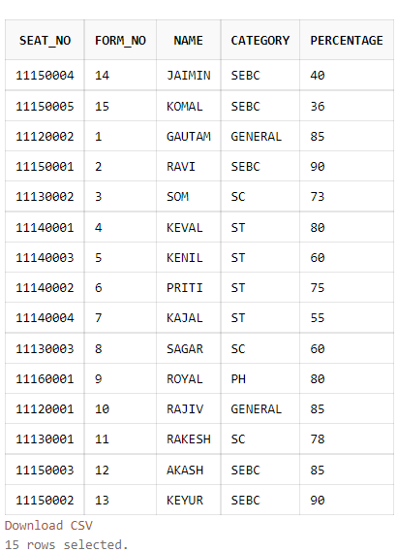

2. For the table STUDENT( Rollno, Name, Mrks1, Mrks2, Mrks3, Percentage), write a PL/SQL code which calculates the percentage for each student assuming passing marks as 40 and total marks as 100 for each subject. Also display the details about the students who have scored the highest in each subject.For the following tables, CANDIDATE (CID, CNAME, CADDRESS, CBIRTH_DT)TEST (TID, TNAME, TOT_MRKS, PASS_MKS)TEST_CENTRE (TCID, LOCATION, MGR, CAPACITY)TEST_TAKEN (CID, TID, TCID, TEST_DT, SCORE)

create table student(
rollno number(5) primary key,
name varchar(20),
mrks1 number(5),
mrks2 number(5),
mrks3 number(5),
percentage number(5));

insert into student(rollno,name,mrks1,mrks2,mrks3) values(1,'ASHISH',99,98,97);
insert into student(rollno,name,mrks1,mrks2,mrks3) values(2,'RAHUL',81,82,83);
insert into student(rollno,name,mrks1,mrks2,mrks3) values(3,'ROHIT',79,80,81);
insert into student(rollno,name,mrks1,mrks2,mrks3) values(4,'JAY',65,76,78);
insert into student(rollno,name,mrks1,mrks2,mrks3) values(5,'KEVAL',85,81,94);
insert into student(rollno,name,mrks1,mrks2,mrks3) values(6,'MEHUL',60,50,40);
insert into student(rollno,name,mrks1,mrks2,mrks3) values(7,'KARTIK',45,55,65);

PL/SQL
declare
cursor c1 is select * from student;

per student.percentage%type;

cursor c2 is
select rollno,name,mrks1 from student
where mrks1=(select max(mrks1) from student);

cursor c3 is
select rollno,name,mrks2 from student
where mrks2=(select max(mrks2) from student);

cursor c4 is
select rollno,name,mrks3 from student
where mrks3=(select max(mrks3) from student);

begin
for r1 in c1
loop
per:=100*(r1.mrks1+r1.mrks2+r1.mrks3)/300;
update student set percentage=per
where rollno=r1.rollno;
end loop;

dbms_output.put_line('Highest marks in subject:-1');
for r in c2
loop
dbms_output.put_line('Roll no:- '||r.rollno||' '||' Marks:- '||r.mrks1);
end loop;

dbms_output.put_line('Highest marks in subject:-2');
for r in c3
loop
dbms_output.put_line('Roll no:- '||r.rollno||' '||' Marks:- '||r.mrks2);
end loop;

dbms_output.put_line('Highest marks in subject:-3');
for r in c4
loop
dbms_output.put_line('Roll no:- '||r.rollno||' '||' Marks:- '||r.mrks3);
end loop;
end;
/

select * from student;

create table candidate(
cid number(5) primary key,
cname varchar(20),
caddress varchar(20),
cbirth_dt date);

create table test(
tid number(5) primary key,
tname varchar2(20),
tot_mrks number(6),
pass_mks number(6));

create table test_centre(
tcid number(5) primary key,
location varchar2(20),
mgr varchar(20),
capacity number(6));

create table test_taken(
cid number(5) references candidate(cid),
tid number(5) references test(tid),
tcid number(5) references test_centre(tcid),
test_dt date,
score number(6),
constraint pk_test_taken primary key(cid,tid,tcid));

insert into candidate values(1,'ASHISH','MUMBAI',to_date('12-4-2002','dd-mm-yyyy'));
insert into candidate values(2,'MAYUR','SURAT',to_date('10-4-1999','dd-mm-yyyy'));
insert into candidate values(3,'VIJAY','VADODARA',to_date('20-5-2005','dd-mm-yyyy'));
insert into candidate values(4,'PRAKASH','RAJKOT',to_date('23-5-2007','dd-mm-yyyy'));
insert into candidate values(5,'MEHUL','MEHSANA',to_date('22-3-2002','dd-mm-yyyy'));

insert into test values(1,'SCIENCE',100,40);
insert into test values(2,'ENGLISH',100,50);
insert into test values(3,'SANSKRIT',100,60);
insert into test values(4,'MATHS',100,70);
insert into test values(5,'HINDI',100,80);

insert into test_centre values(1,'AHMDABAD',100,50);
insert into test_centre values(2,'MUMBAI',100,40);
insert into test_centre values(3,'PORBANDAR',100,60);
insert into test_centre values(4,'SURAT',100,50);

insert into test_taken values(1,1,1,to_date('11-4-2022','dd-mm-yyyy'),80);
insert into test_taken values(1,2,1,to_date('6-4-2022','dd-mm-yyyy'),85);
insert into test_taken values(1,3,1,to_date('7-4-2022','dd-mm-yyyy'),95);
insert into test_taken values(2,1,2,to_date('1-5-2022','dd-mm-yyyy'),60);
insert into test_taken values(2,2,2,to_date('2-6-2022','dd-mm-yyyy'),70);
insert into test_taken values(2,3,2,to_date('3-7-2022','dd-mm-yyyy'),80);
insert into test_taken values(3,1,1,to_date('1-8-2022','dd-mm-yyyy'),70);
insert into test_taken values(3,2,1,to_date('2-9-2022','dd-mm-yyyy'),75);
insert into test_taken values(3,3,1,to_date('3-10-2022','dd-mm-yyyy'),65);
insert into test_taken values(4,1,1,to_date('1-1-2022','dd-mm-yyyy'),82);
insert into test_taken values(4,2,1,to_date('2-5-2022','dd-mm-yyyy'),72);
insert into test_taken values(4,3,1,to_date('3-7-2022','dd-mm-yyyy'),92);
insert into test_taken values(5,1,3,to_date('1-2-2022','dd-mm-yyyy'),56);
insert into test_taken values(5,2,3,to_date('2-2-2022','dd-mm-yyyy'),66);
insert into test_taken values(5,3,3,to_date('3-2-2022','dd-mm-yyyy'),76);

PL/SQL
declare

cursor c1(t test_taken.tid%type) is
select * from test_taken
where tid=t and score>
(select avg(score) from test_taken where tid=t);

cursor c2(tc test_taken.tcid%type) is
select test_dt from
(select test_dt,count(*) c
from test_taken
where tcid=tc
group by test_dt
order by test_dt)
where c=(select capacity
from test_centre
where tcid=tc);

r1 test_taken%rowtype;
r2 test_taken.test_dt%type;
tid test_taken.tid%type;
tcid test_taken.tcid%type;

begin

tid:=1;
tcid:=1;

dbms_output.put_line('Candidate scored more than average in given test');

open c1(tid);
loop
fetch c1 into r1;
exit when c1%notfound;

dbms_output.put_line('CANDIDATE='||r1.cid);
dbms_output.put_line('TEST='||r1.tid);
dbms_output.put_line('TESTCENTER='||r1.tcid);
dbms_output.put_line('TESTDATE='||r1.test_dt);
dbms_output.put_line('SCORE='||r1.score);
dbms_output.put_line('___');
end loop;
close c1;
dbms_output.put_line('TEST CENTER IS FULL:');

for r2 in c2(tcid)
loop
dbms_output.put_line(r2.test_dt);
end loop;

end;
/

PL/SQL

declare
cursor c1(id test_taken.cid%type) is
select * from test_taken
where cid=id;

cid test_taken.cid%type;
sub test.tname%type;
highest test_taken.score%type;

begin

cid:=1;

dbms_output.put_line('Candidate apperared in following tests:-');

for r1 in c1(cid)
loop
select tname into sub
from test
where tid=r1.tid;

select max(score) into highest
from test_taken
where tid=r1.tid;

dbms_output.put_line('TEST ID:- '||r1.tid);
dbms_output.put_line('SCORE:- '||r1.score);
dbms_output.put_line('TEST NAME:- '||sub);
dbms_output.put_line('HIGHEST:- '||highest);
dbms_output.put_line('--');
end loop;

end;
/

select *
from test t inner join test_taken tt
on t.tid=tt.tid
where tt.cid=1;

select
t.tid,t.tname,t.tot_mrks,t.pass_mks,
tt.cid,tt.test_dt,tt.score,
(select max(score)
from test_taken
where tid=t.tid
group by tid) as highest
from test t inner join test_taken tt
on t.tid=tt.tid
where tt.cid=1;

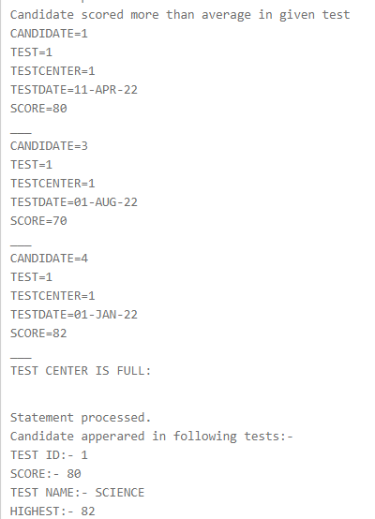

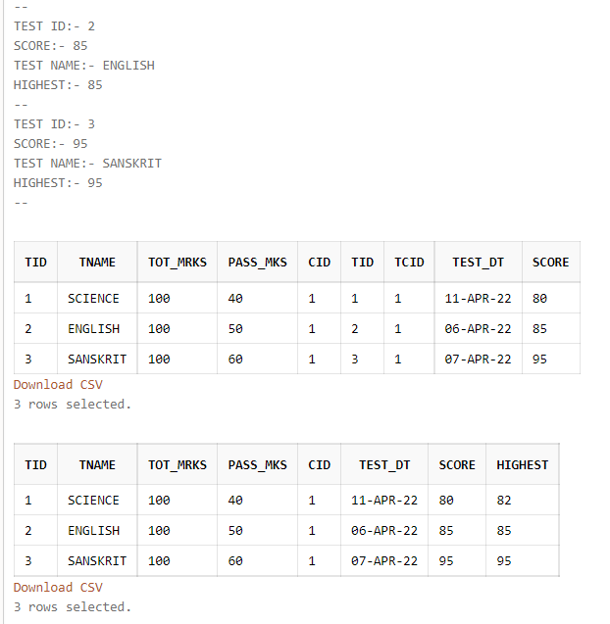

3. Write a PL/SQL block which will accept the test id and test centre id from the user and display details about all those candidates who have scored more than average for that test. Also display details about the dates on which that test centre had full attendance.

create table candidate(
cid number(5) primary key,
cname varchar(20),
caddress varchar(20),
cbirth_dt date);

create table test(
tid number(5) primary key,
tname varchar2(20),
tot_mrks number(6),
pass_mks number(6));

create table test_centre(
tcid number(5) primary key,
location varchar2(20),
mgr varchar(20),
capacity number(6));

create table test_taken(
cid number(5) references candidate(cid),
tid number(5) references test(tid),
tcid number(5) references test_centre(tcid),
test_dt date,
score number(6),
constraint pk_test_taken primary key(cid,tid,tcid));

insert into candidate values(1,'ASHISH','MUMBAI',to_date('12-4-2002','dd-mm-yyyy'));
insert into candidate values(2,'MAYUR','SURAT',to_date('10-4-1999','dd-mm-yyyy'));
insert into candidate values(3,'VIJAY','VADODARA',to_date('20-5-2005','dd-mm-yyyy'));
insert into candidate values(4,'PRAKASH','RAJKOT',to_date('23-5-2007','dd-mm-yyyy'));
insert into candidate values(5,'MEHUL','MEHSANA',to_date('22-3-2002','dd-mm-yyyy'));

insert into test values(1,'SCIENCE',100,40);
insert into test values(2,'ENGLISH',100,50);
insert into test values(3,'SANSKRIT',100,60);
insert into test values(4,'MATHS',100,70);
insert into test values(5,'HINDI',100,80);

insert into test_centre values(1,'AHMDABAD',100,50);
insert into test_centre values(2,'MUMBAI',100,40);
insert into test_centre values(3,'PORBANDAR',100,60);
insert into test_centre values(4,'SURAT',100,50);

insert into test_taken values(1,1,1,to_date('11-4-2022','dd-mm-yyyy'),80);
insert into test_taken values(1,2,1,to_date('6-4-2022','dd-mm-yyyy'),85);
insert into test_taken values(1,3,1,to_date('7-4-2022','dd-mm-yyyy'),95);
insert into test_taken values(2,1,2,to_date('1-5-2022','dd-mm-yyyy'),60);
insert into test_taken values(2,2,2,to_date('2-6-2022','dd-mm-yyyy'),70);
insert into test_taken values(2,3,2,to_date('3-7-2022','dd-mm-yyyy'),80);
insert into test_taken values(3,1,1,to_date('1-8-2022','dd-mm-yyyy'),70);
insert into test_taken values(3,2,1,to_date('2-9-2022','dd-mm-yyyy'),75);
insert into test_taken values(3,3,1,to_date('3-10-2022','dd-mm-yyyy'),65);
insert into test_taken values(4,1,1,to_date('1-1-2022','dd-mm-yyyy'),82);
insert into test_taken values(4,2,1,to_date('2-5-2022','dd-mm-yyyy'),72);
insert into test_taken values(4,3,1,to_date('3-7-2022','dd-mm-yyyy'),92);
insert into test_taken values(5,1,3,to_date('1-2-2022','dd-mm-yyyy'),56);
insert into test_taken values(5,2,3,to_date('2-2-2022','dd-mm-yyyy'),66);
insert into test_taken values(5,3,3,to_date('3-2-2022','dd-mm-yyyy'),76);

PL/SQL
declare

cursor c1(t test_taken.tid%type) is
select * from test_taken
where tid=t and score>
(select avg(score) from test_taken where tid=t);

cursor c2(tc test_taken.tcid%type) is
select test_dt from
(select test_dt,count(*) c
from test_taken
where tcid=tc
group by test_dt
order by test_dt)
where c=(select capacity
from test_centre
where tcid=tc);

r1 test_taken%rowtype;
r2 test_taken.test_dt%type;
tid test_taken.tid%type;
tcid test_taken.tcid%type;

begin

tid:=1;
tcid:=1;

dbms_output.put_line('Candidate scored more than average in given test');

open c1(tid);
loop
fetch c1 into r1;
exit when c1%notfound;

dbms_output.put_line('CANDIDATE='||r1.cid);
dbms_output.put_line('TEST='||r1.tid);
dbms_output.put_line('TESTCENTER='||r1.tcid);
dbms_output.put_line('TESTDATE='||r1.test_dt);
dbms_output.put_line('SCORE='||r1.score);
dbms_output.put_line('___');

end loop;
close c1;

dbms_output.put_line('TEST CENTER IS FULL:');

for r2 in c2(tcid)
loop
dbms_output.put_line(r2.test_dt);
end loop;

end;
/

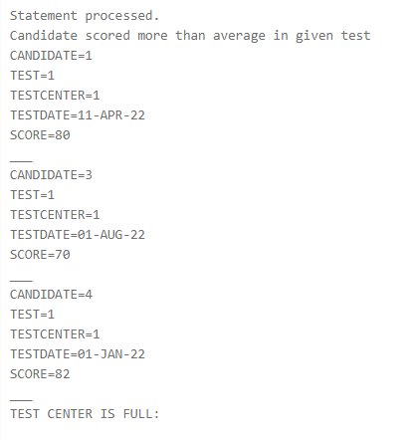

4. Write a PL/SQL block, which will accept the candidate id from the user and for this user display details about all the tests that he has appeared for as well as the details about his scores and the maximum scores of those tests.

create table candidate(
cid number(5) primary key,
cname varchar(20),
caddress varchar(20),
cbirth_dt date);

create table test(
tid number(5) primary key,
tname varchar2(20),
tot_mrks number(6),
pass_mks number(6));

create table test_centre(
tcid number(5) primary key,
location varchar2(20),
mgr varchar(20),
capacity number(6));

create table test_taken(
cid number(5) references candidate(cid),
tid number(5) references test(tid),
tcid number(5) references test_centre(tcid),
test_dt date,
score number(6),
constraint pk_test_taken primary key(cid,tid,tcid));

insert into candidate values(1,'ASHISH','MUMBAI',to_date('12-4-2002','dd-mm-yyyy'));
insert into candidate values(2,'MAYUR','SURAT',to_date('10-4-1999','dd-mm-yyyy'));
insert into candidate values(3,'VIJAY','VADODARA',to_date('20-5-2005','dd-mm-yyyy'));
insert into candidate values(4,'PRAKASH','RAJKOT',to_date('23-5-2007','dd-mm-yyyy'));
insert into candidate values(5,'MEHUL','MEHSANA',to_date('22-3-2002','dd-mm-yyyy'));

insert into test values(1,'SCIENCE',100,40);
insert into test values(2,'ENGLISH',100,50);
insert into test values(3,'SANSKRIT',100,60);
insert into test values(4,'MATHS',100,70);
insert into test values(5,'HINDI',100,80);

insert into test_centre values(1,'AHMDABAD',100,50);
insert into test_centre values(2,'MUMBAI',100,40);
insert into test_centre values(3,'PORBANDAR',100,60);
insert into test_centre values(4,'SURAT',100,50);

insert into test_taken values(1,1,1,to_date('11-4-2022','dd-mm-yyyy'),80);
insert into test_taken values(1,2,1,to_date('6-4-2022','dd-mm-yyyy'),85);
insert into test_taken values(1,3,1,to_date('7-4-2022','dd-mm-yyyy'),95);
insert into test_taken values(2,1,2,to_date('1-5-2022','dd-mm-yyyy'),60);
insert into test_taken values(2,2,2,to_date('2-6-2022','dd-mm-yyyy'),70);
insert into test_taken values(2,3,2,to_date('3-7-2022','dd-mm-yyyy'),80);
insert into test_taken values(3,1,1,to_date('1-8-2022','dd-mm-yyyy'),70);
insert into test_taken values(3,2,1,to_date('2-9-2022','dd-mm-yyyy'),75);
insert into test_taken values(3,3,1,to_date('3-10-2022','dd-mm-yyyy'),65);
insert into test_taken values(4,1,1,to_date('1-1-2022','dd-mm-yyyy'),82);
insert into test_taken values(4,2,1,to_date('2-5-2022','dd-mm-yyyy'),72);
insert into test_taken values(4,3,1,to_date('3-7-2022','dd-mm-yyyy'),92);
insert into test_taken values(5,1,3,to_date('1-2-2022','dd-mm-yyyy'),56);
insert into test_taken values(5,2,3,to_date('2-2-2022','dd-mm-yyyy'),66);
insert into test_taken values(5,3,3,to_date('3-2-2022','dd-mm-yyyy'),76);

declare
cursor c1(id test_taken.cid%type) is
select * from test_taken
where cid=id;

cid test_taken.cid%type;
sub test.tname%type;
highest test_taken.score%type;

begin

cid:=1;

dbms_output.put_line('Candidate apperared in following tests:-');

for r1 in c1(cid)
loop
select tname into sub
from test
where tid=r1.tid;

select max(score) into highest
from test_taken
where tid=r1.tid;

dbms_output.put_line('TEST ID '||r1.tid);
dbms_output.put_line('SCORE'||r1.score);
dbms_output.put_line('TEST NAME'||sub);
dbms_output.put_line('HIGHEST '||highest);
dbms_output.put_line('--');
end loop;

end;
/

